

Living a Healthy Life for a Happier You

By Nery Enrique Escamilla Recinos Guatemala, Guatemala City. October 9th, 2024

What & Why

HEALTH PROBLEM

Lack of Exercise: Most people

lead sedentary lives and are

not active bodily.

Obesity: More than four out of

10 adults in the U.S. are

considered obese — a likely

cause of multiple chronic

diseases.

Mental Health: Physical

inactivity and poor nutrition

are both related to increasing

rates of anxiety and

depression.

SEVERITY AND IMPACT
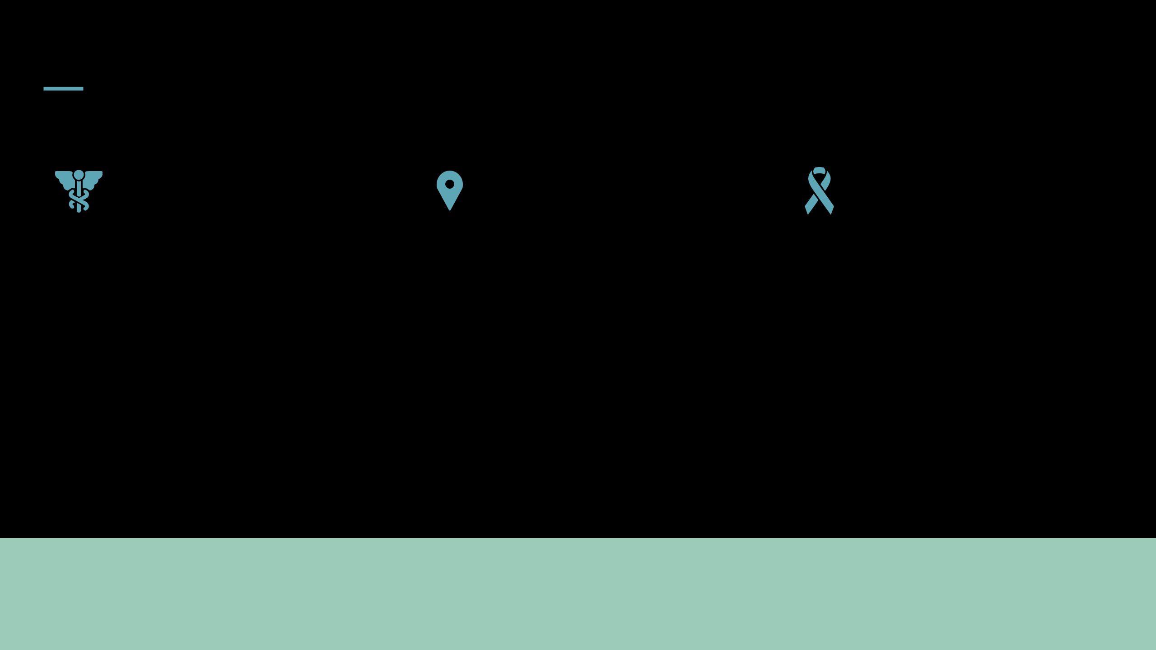

Obesity increases the risk of

heart disease, diabetes, and

some cancers remarkably.

Decreased quality of life can be

a result of mental health, poor

job performance, and a drug

that impacts the mind can

decrease quality of life. They

can cause a decrease in life

expectancy and decrease in

overall community well being.

NEED FOR AWARENESS

This will not only help us raise awareness to assist people to make choices which develop into healthier lifestyles, thus lowering obesity as well as the number of related diseases. What we are trying to do is educate people on why exercise and nutrition are so important to give them the ability and the empowerment to make informed decisions with their health.

THIS SLIDE AIMS TO STIR ACTION AND ENGAGEMENT FROM THE AUDIENCE THAT IS AWARE ON THE HEALTH PROBLEM, ITS IMPORTANCE AND THE NEED TO RAISE AWARENESS ON THE PROBLEM.

Who & How

WHO IS AFFECTED

Children and Adolescents

Adults

Seniors

STRATEGY #1
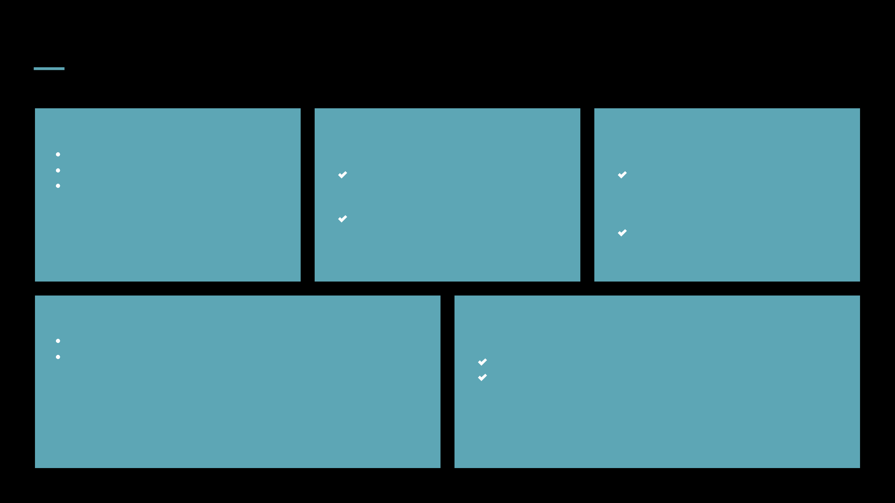

Community Workshops and Events:

Sponsor health fairs, fitness challenges and

cooking demonstrations in schools and

community center.

Make nutrition, meal planning, and

physical activity workshops free.

STRATEGY #3

Partnerships:

Inject federal programs and annual funding primarily into the renewable energy sector, alongside local health programs, gyms and schools.

Making resource materials like brochures and flyers so we can give out to them easy.

TARGET AUDIENCE

Primary Audience: Children and teenagers

Secondary Audience: Those who are young adults and working professionals. Local leaders and community organizations, who can partner with Occupy to help spread the message.

STRATEGY #2

Social Media Campaigns:

Like Instagram, TikTok, Facebook, share engaging content on them.

The way to reach a bigger audience is to work with local influencers or health advocates.

Taking Action

INCREASE PHYSICAL ACTIVITY:

Promote regular exercise, trying for at least 150 minutes of moderate intensity aerobic activity every week.

Promote joining local sports teams, fitness classes, or walking groups to build community and accountability.

PRIORITIZE MENTAL

HEALTH:

Maintaining a strong relationship with anything that opens their heart wider, anything that creates a sense of peace in their mind.

Work to create open conversations around mental health and breaking down stigma so that whenever needed we will seek help.

ADOPT HEALTHIER EATING HABITS:
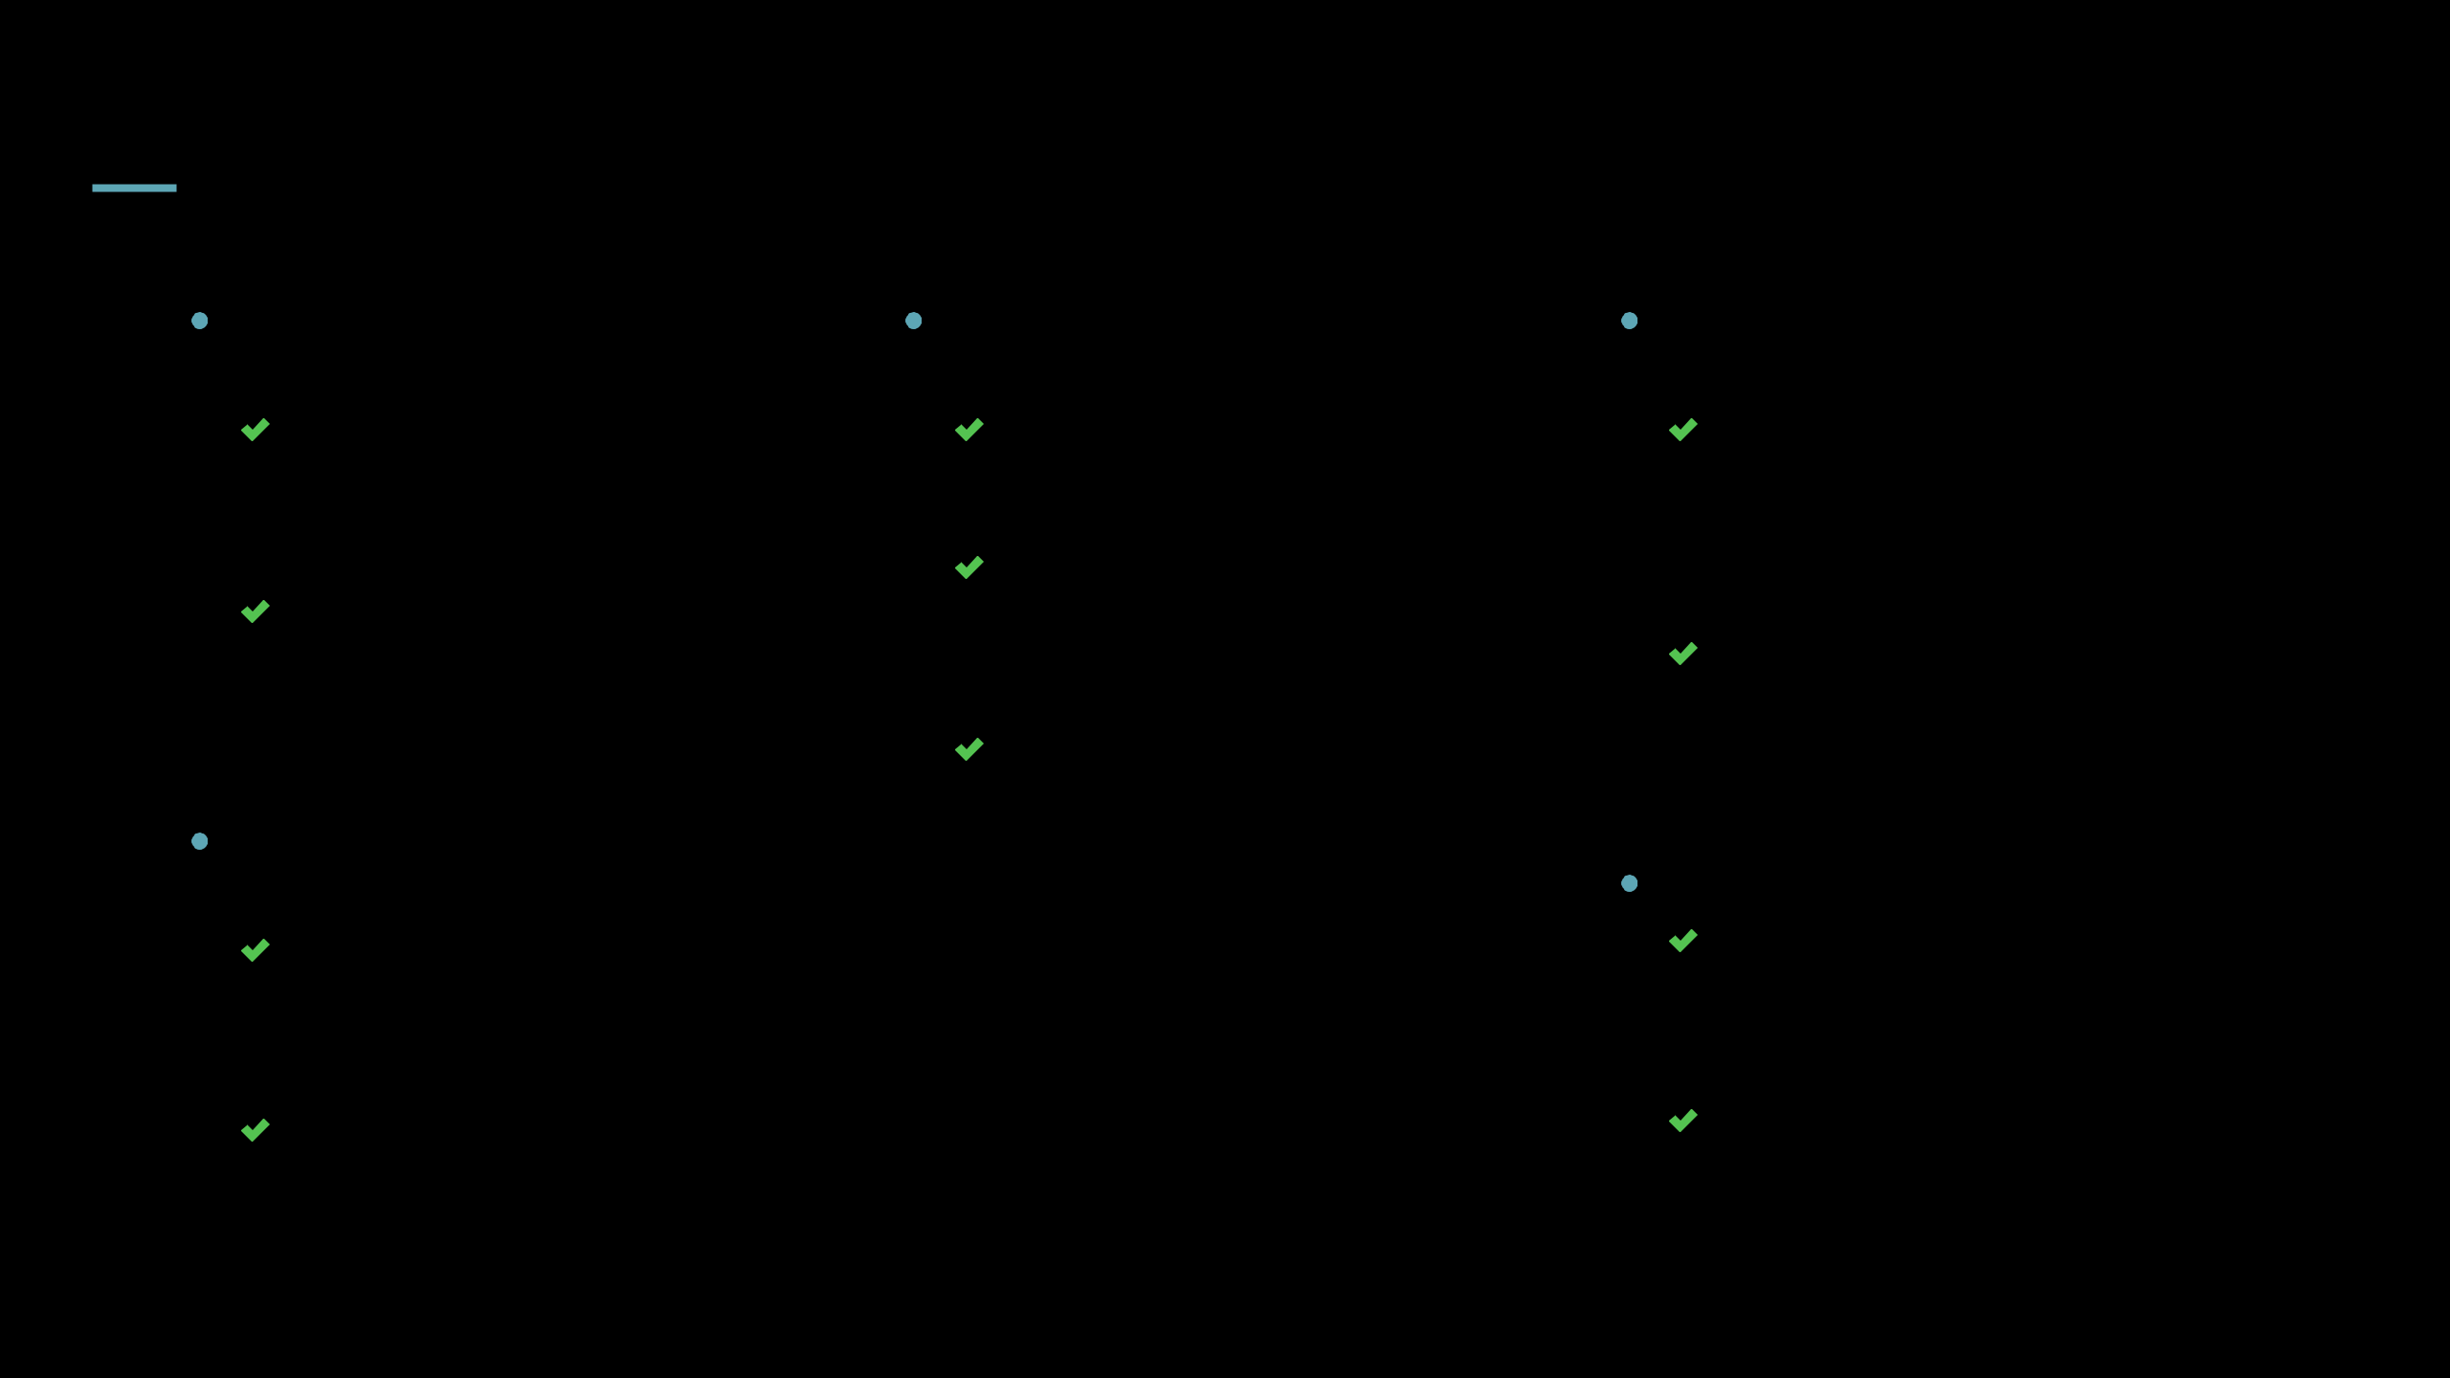
Promote meal planning and preparation so you don’t have to rely so much on processed foods.

It would be suggested that the daily diet contains more fruits, vegetables, whole grains, and lean proteins.

Offer reading nutrition label and making healthier food choices when we eat out.

CONTINUOUS

ENGAGEMENT:

Share success stories, tips, and ongoing resources to keep the community inspired and in the loop through use of social media and newsletters.

Seek to stimulate feedback so that programs are adaptable and get better based on the needs of the community.

RESOURCE PROVISION:

Empower the community through creating and sharing educational material such as exercise guide, healthy cooking guide, etc.

Create an online portal or app where people can get resource, follow their progress and find local health events.

References

ACADEMIC SOURCES | ONLINE RESOURCES | NATIONAL LIBRARY OF MEDICINE
Smith, J. (2020). “The Impact of Diet on | National Center for Health Statistics | Impact of diet on health and longevity in
Health.” Health Journal, 45(2), 123-130 |  | London 1850–1880

THE CAMPAIGNS COMBINE REFERENCE FROM A WIDE VARIETY OF RESEARCH; ADDING TO THE THOROUGH RESEARCH ALL OF THE INFORMATION AND RESOURCES USED, SUPPORTING A WELL INFORMED AND EFFECTIVE CAMPAIGN.

